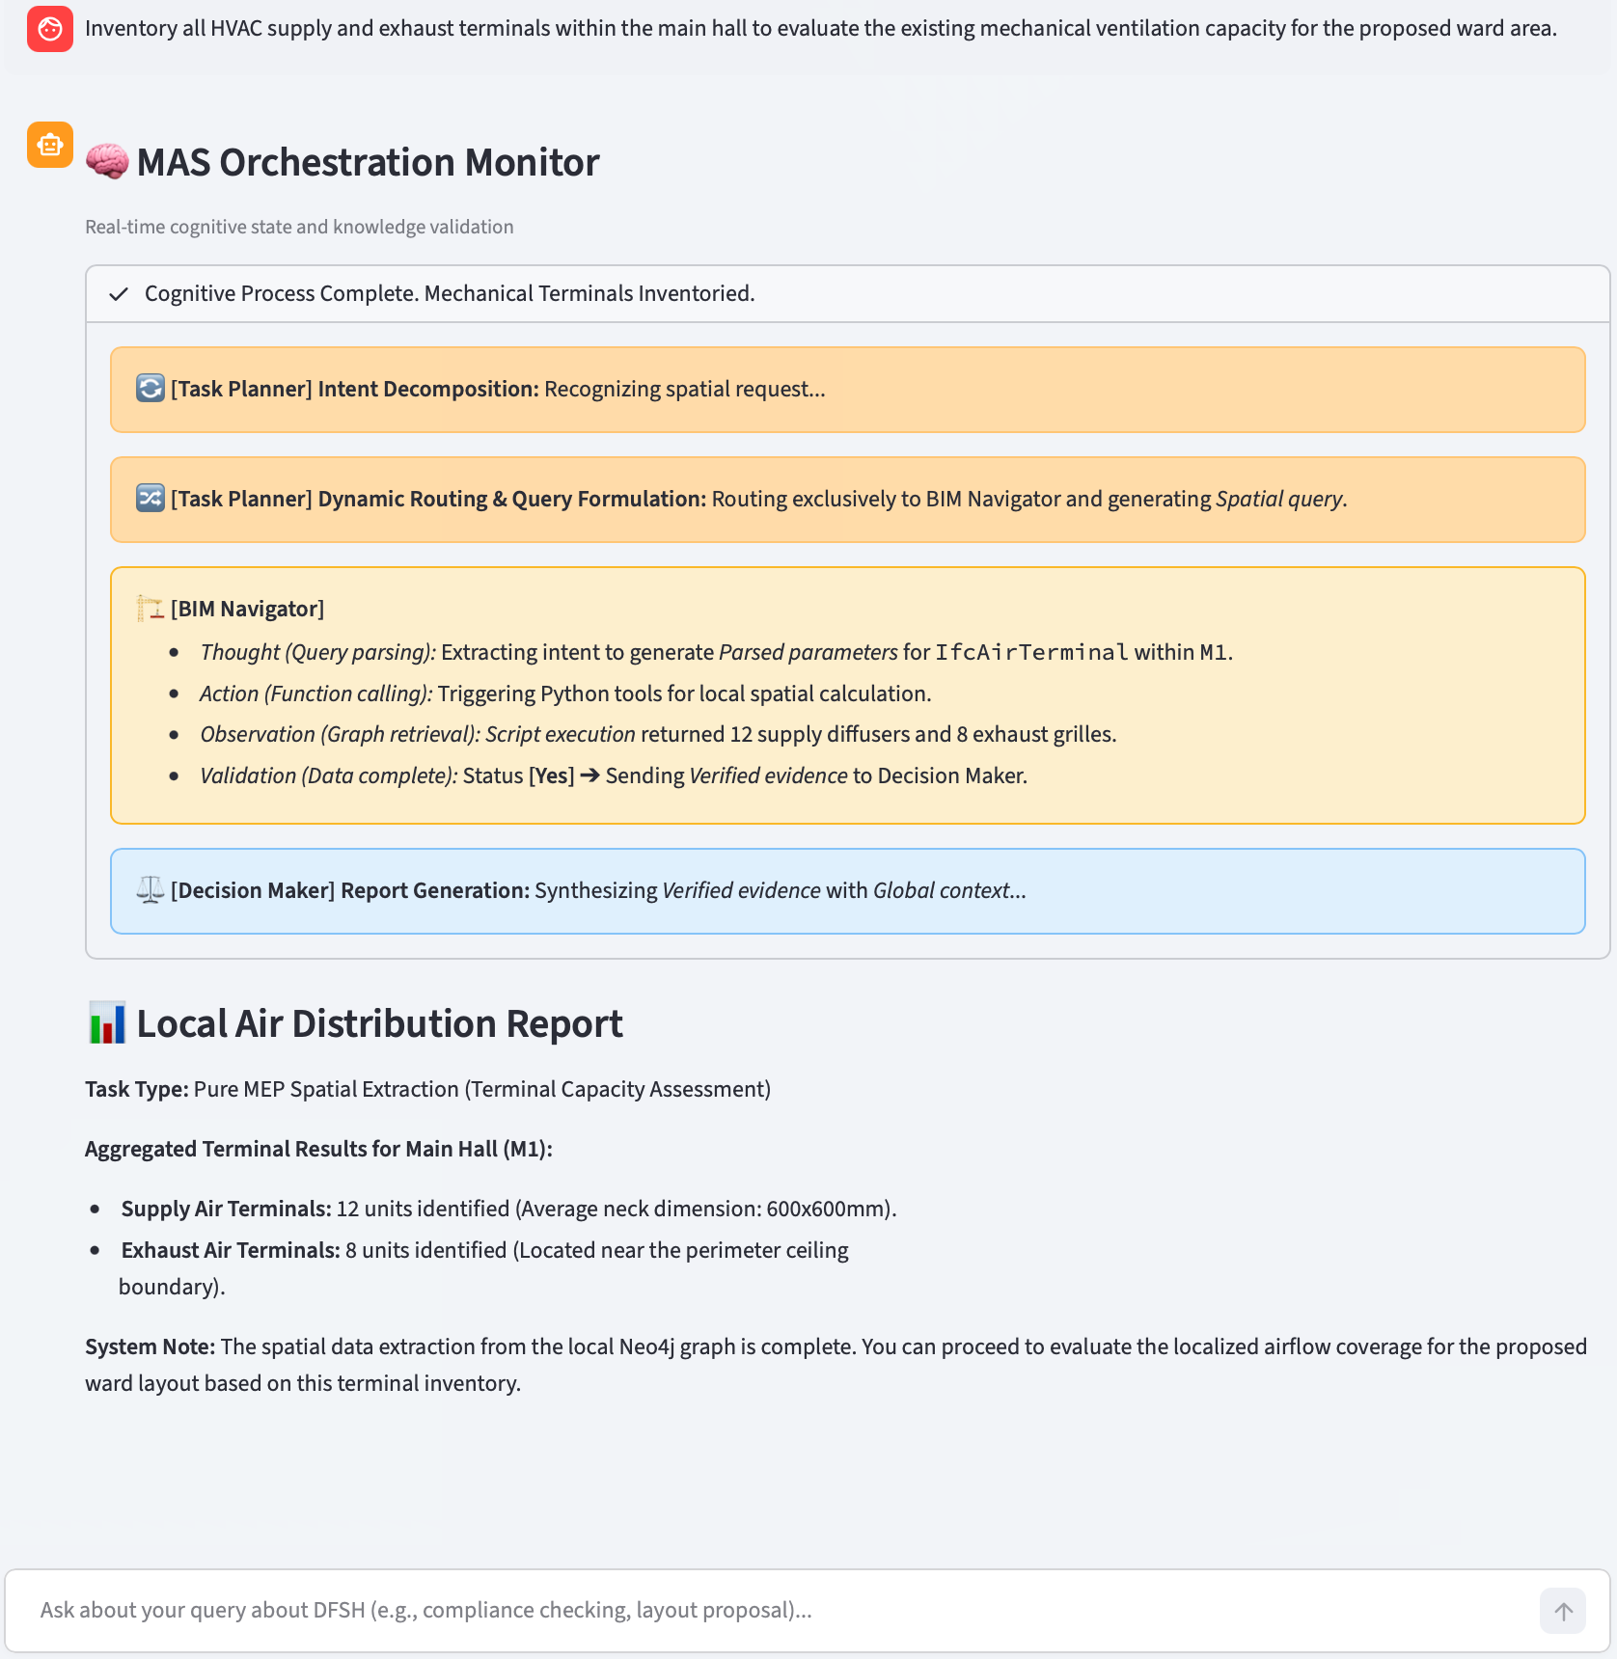
Fig. S1. Single-track reasoning workflow for asset inventorying
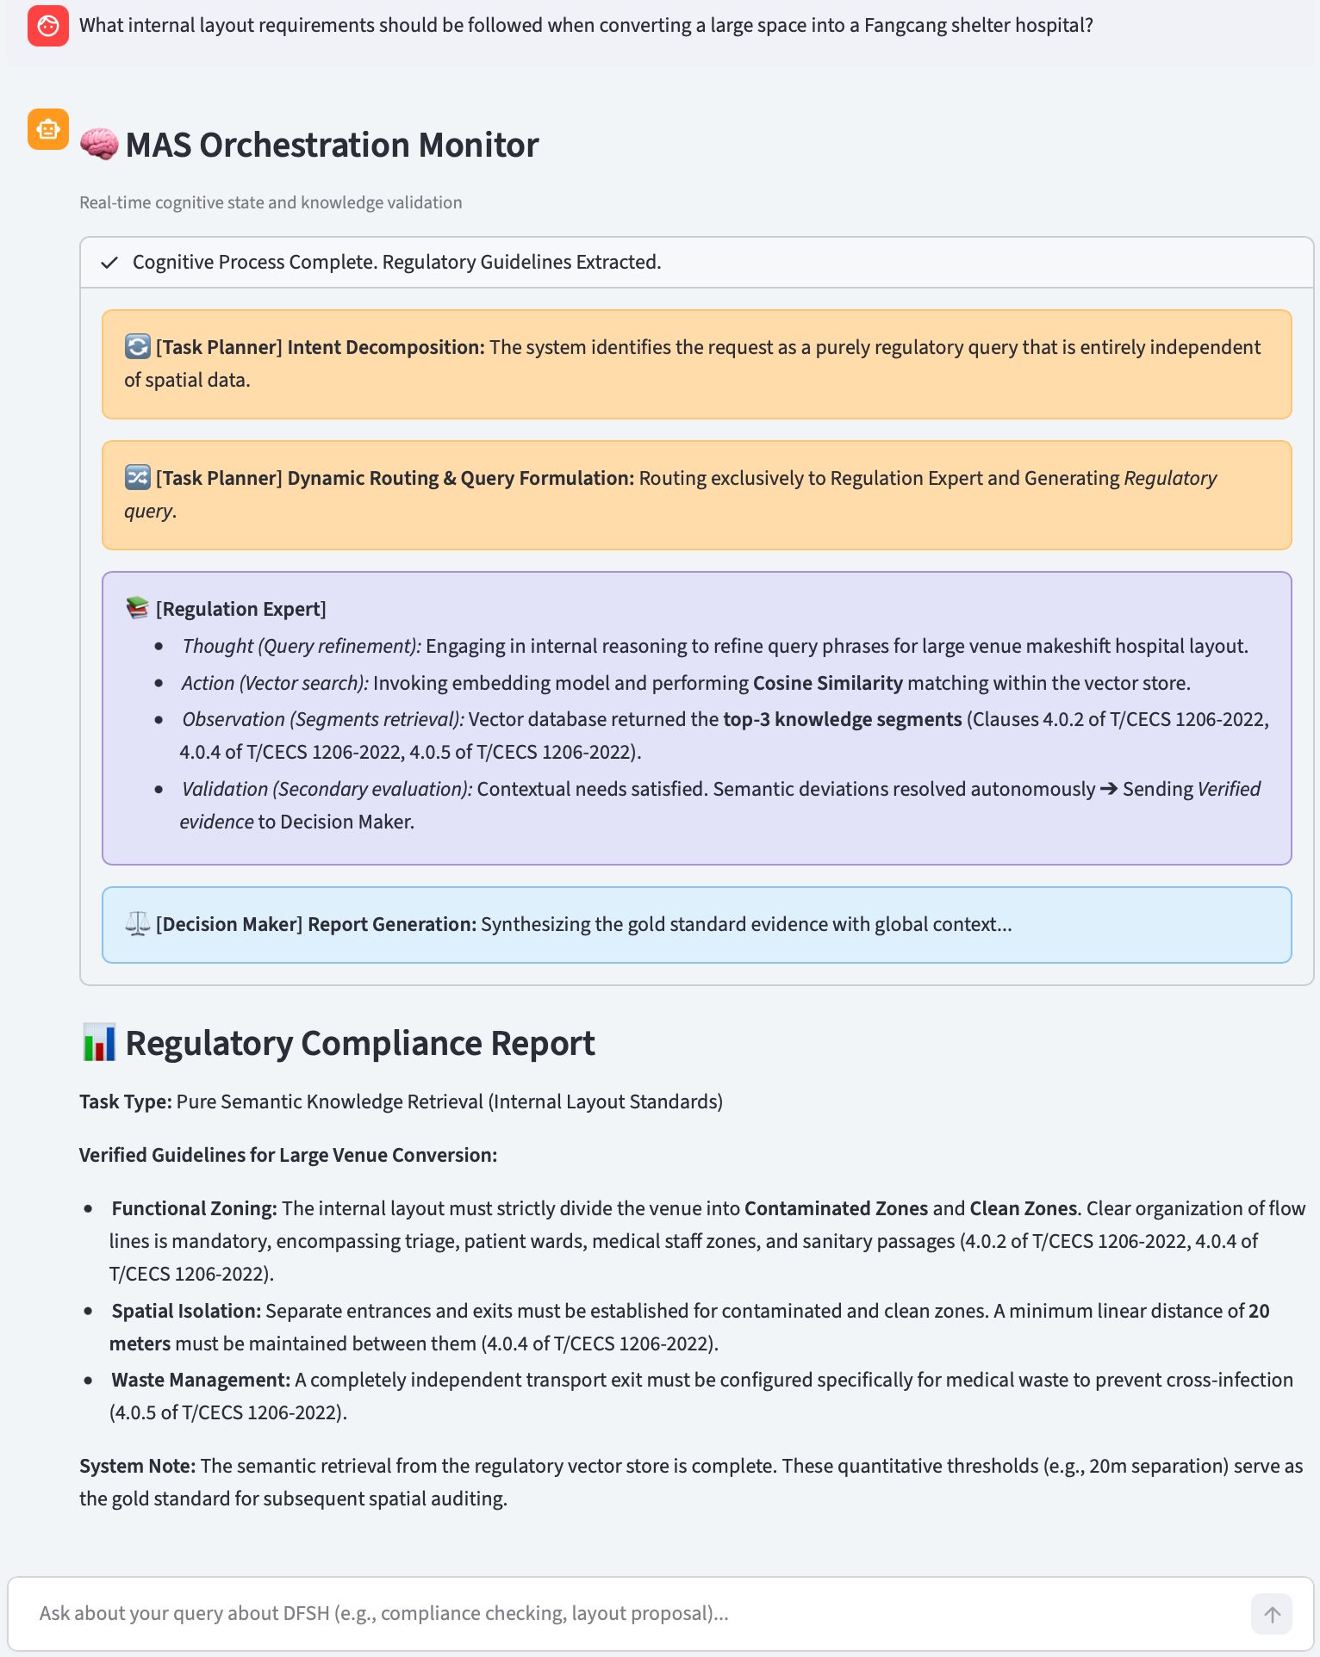
Fig. S2. Single-track reasoning workflow for regulation querying

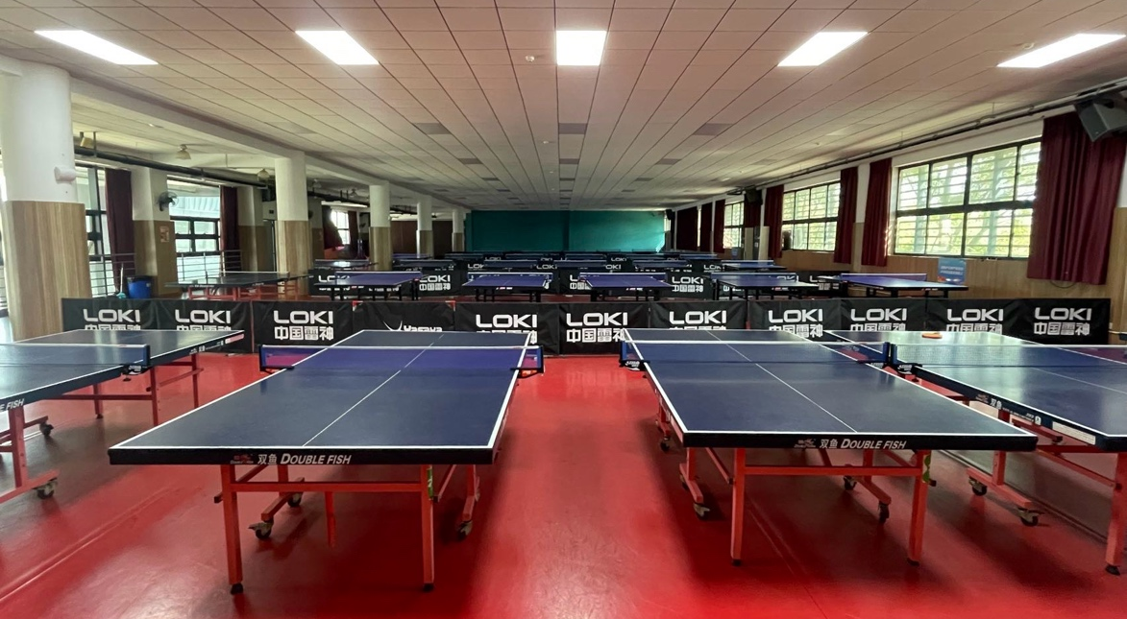
(a) Physical venue of the table tennis hall

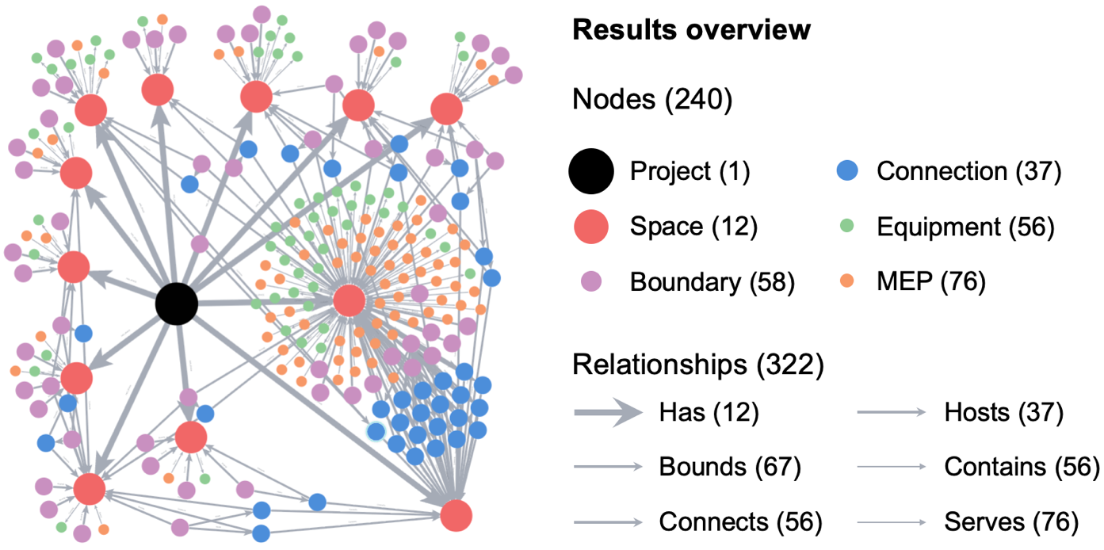
(b) Autonomously generated Spatial KG

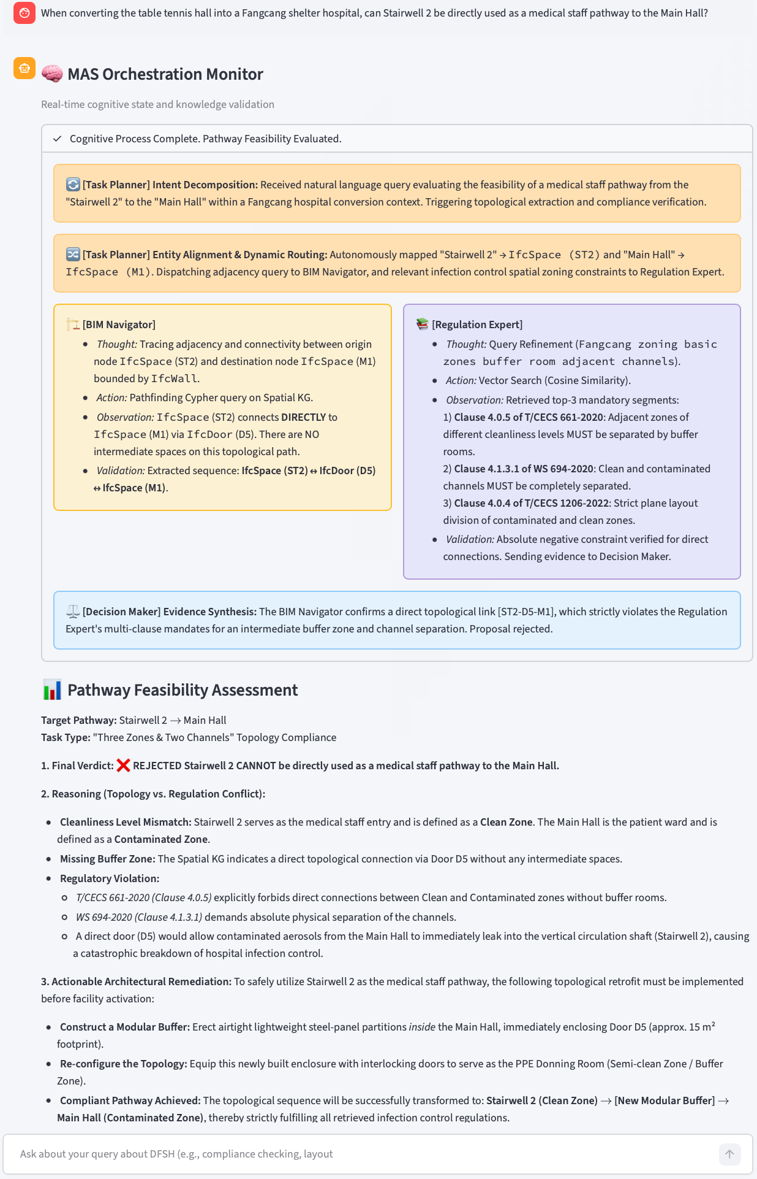
(c) Detailed MAS execution logs for capacity planning
Fig. S3. Supplementary generalizability validation of the proposed framework on an independent table tennis hall

